Contents

Scope 1

Gathering Files For Installation 1

Install OEPE WebLogic/Eclipse Indigo 2

Install Oracle Service Bus 7

Install recommended Oracle patch 13

Configure JIRA Plug-In 15

Configure Subclipse (SVN Plug-In) 25

Install SoapUI plug-in 36

# Scope

This document is written from the perspective of a fresh install, where Oracle Middleware does not yet exist on the target PC. All listed versions have been tested as a new installation; upgrade paths have not been tested.

Target Versions:

* OEPE 11.1.1.8.0
* WebLogic 10.3.6
* OSB 11.1.1.6.0
* Eclipse 3.7.1 Indigo
* Mylyn 3.6.2 (comes bundled with OEPE)
* Mylyn JIRA Connector 3.4.0
* SoapUI 4.0.1
* Subclipse 1.6.x

It is STRONGLY recommended to back up existing workspaces and projects in a safe location if attempting to upgrade from an older version. (I have successfully uninstalled the old version, manually deleted the Oracle\Middleware folder, and installed the newer versions, but have not attempted to load projects created in the old version using the new version.)

This document does not discuss the utility of various features; rather it is intended to focus only on installing and configuring the various components that are needed.

# Gathering Files For Installation

(Files are saved here for easy reference: L:\stonaker\eclipse_setup\*)

The following three files will be needed for this setup:

* oepe-wls-indigo-installer-11.1.1.8.0.201110211138-10.3.6-win32.exe
* ofm_osb_generic_11.1.1.6.0_disk1_1of1.zip
* p13573621_1036_Generic.zip

The latest versions of all files are available from the Oracle download page here: <http://www.oracle.com/technetwork/middleware/service-bus/downloads/index.html>

# Install OEPE WebLogic/Eclipse Indigo

1. Double-click the installer: oepe-wls-indigo-installer-11.1.1.8.0.201110211138-10.3.6-win32.exe
2. Confirm the program launch, then click Next on the Welcome screen:

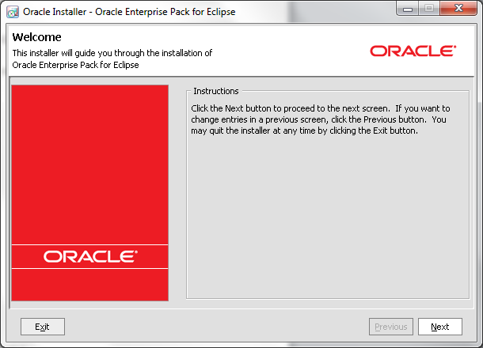

1. Create a new Middleware Home, leave default path C:\Oracle\Middleware:

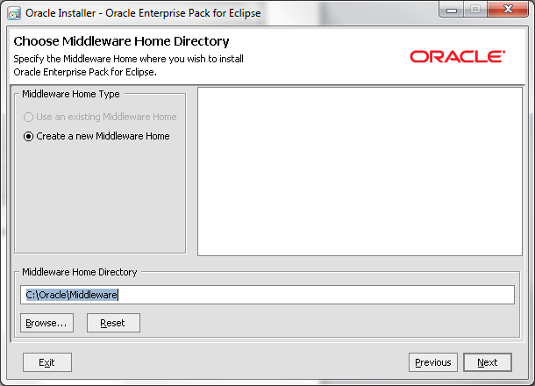

1. Uncheck the box, “I wish to receive security updates…” (unless you already have a Support account registered), then click Next

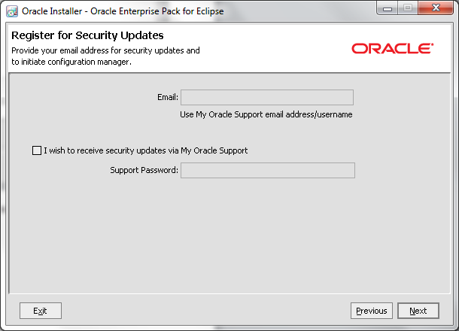

1. Leave the default “Typical” installation, click Next

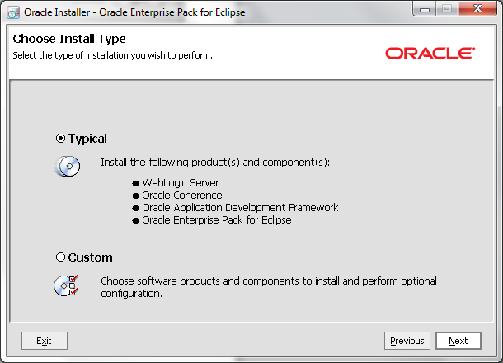

1. Leave the default installation directories; click Next

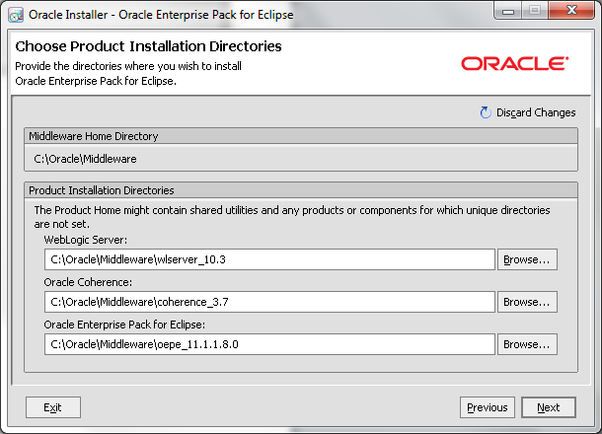

1. Leave the default “All Users”, click Next

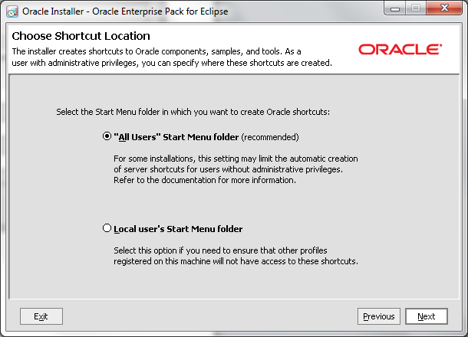

1. Review the Installation Summary dialog and click Next when ready

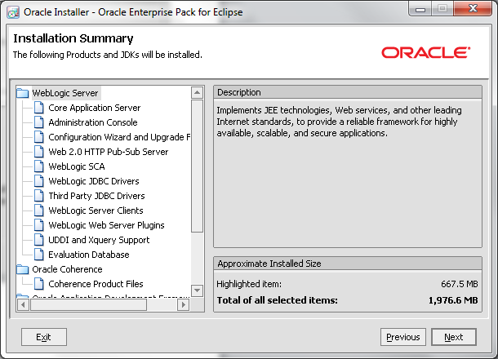

1. Wait while the Oracle software installs:

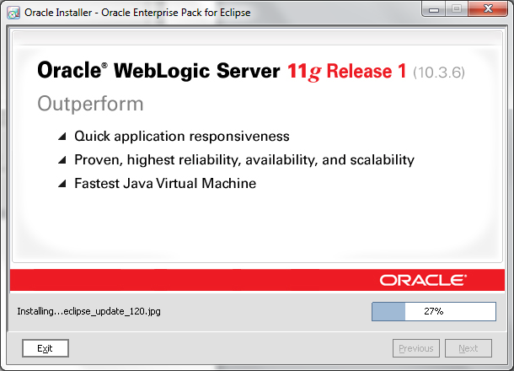

1. Uncheck QuickStart and click Done

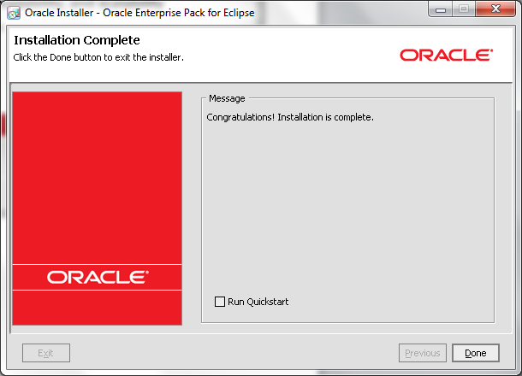

# Install Oracle Service Bus

1. Download and install OSB 11.1.1.6.0:

ofm_osb_generic_11.1.1.6.0_disk1_1of1

1. Unzip into any convenient folder
2. **\*NOTE\*** Run THIS setup file located here (for 64-bit Windows):

\Disk1\install\win64\setup.exe

**\*\*\*The main setup.exe located under Disk1\. does not work correctly! It has a bug in failing to recognize spaces in the path to the JRE, and being unable to quote to include the spaces.**

1. When prompted, enter the path to the JRE. The default path on Win7 64-bit is C:\Program Files\Java\jre7:

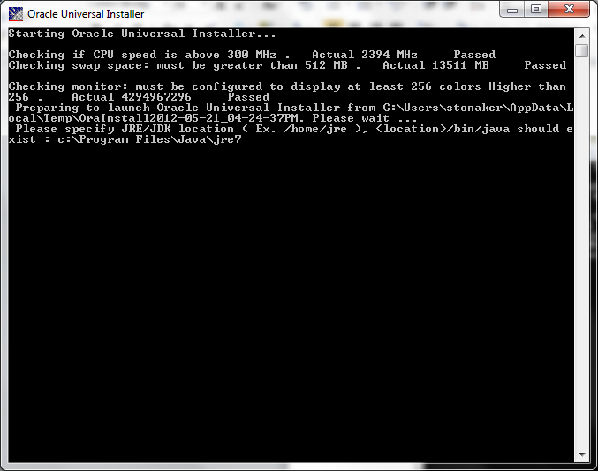

1. Click Next on the Welcome screen:

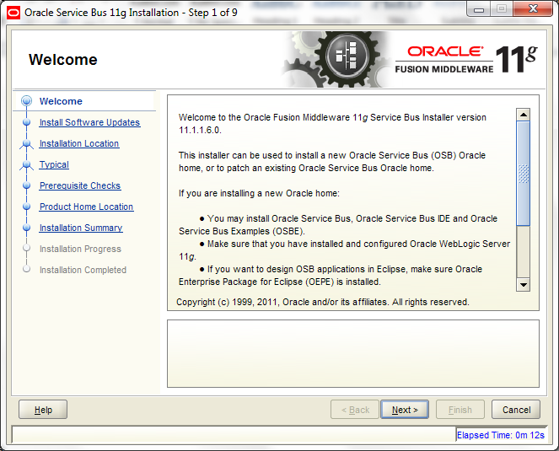

1. Skip Software Updates, click Next:

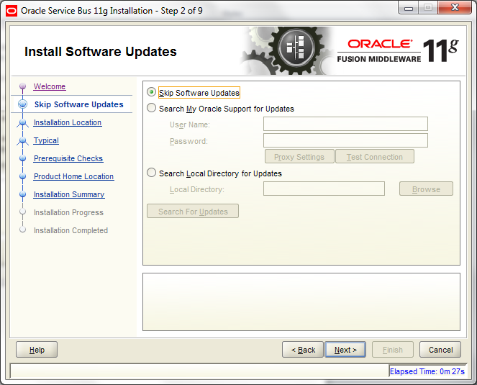

1. Leave the default Middleware directories, click Next:

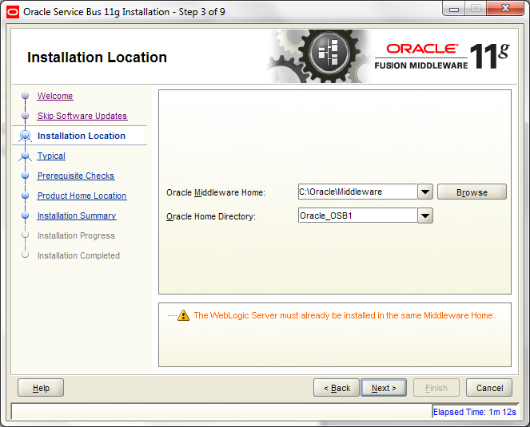

1. Leave “Typical” selected; click Next

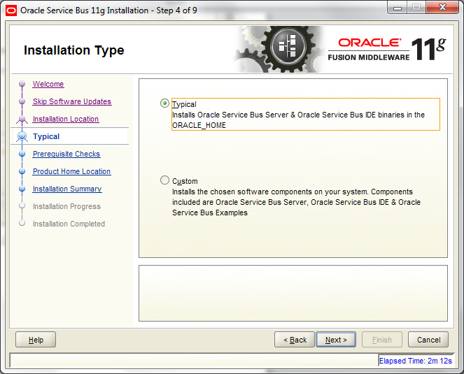

1. When prerequisite checks are complete, click Next

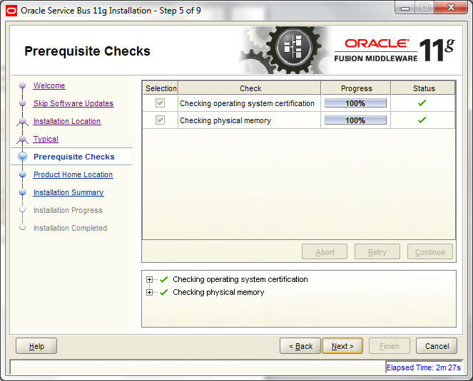

1. Leave the default Home location and click Next:

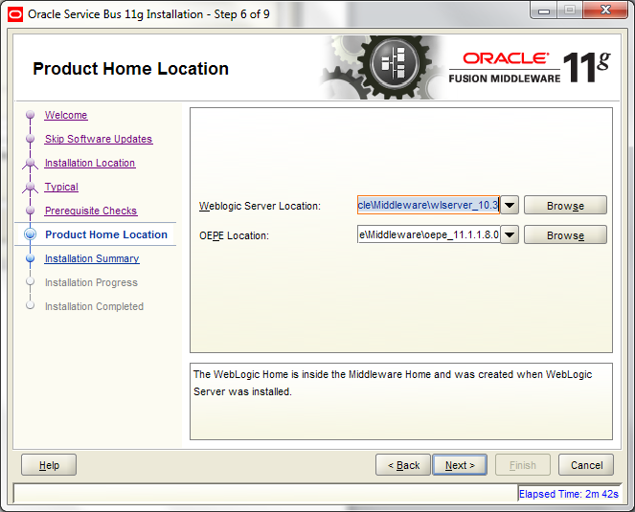

1. Review the Installation Summary, click Install

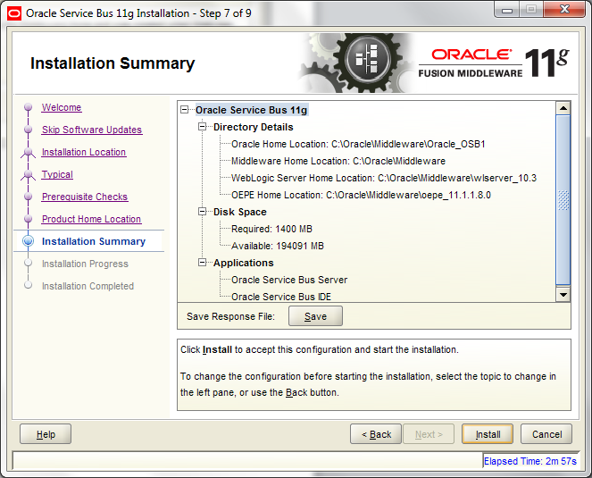

1. Wait while Oracle installs

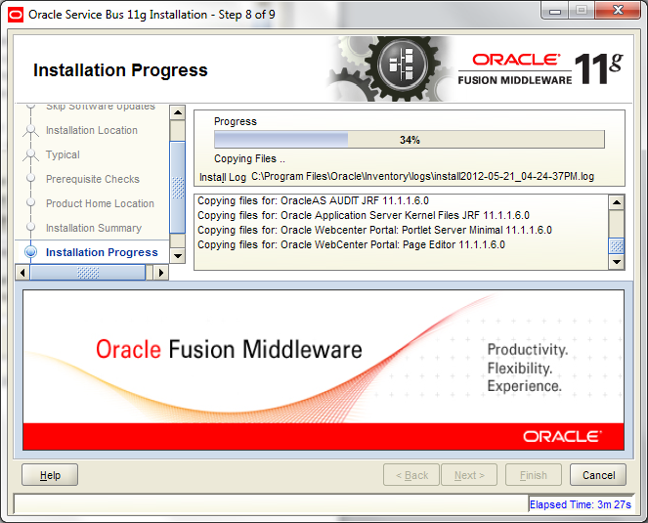

1. Review the installation summary, click Next, then Finish

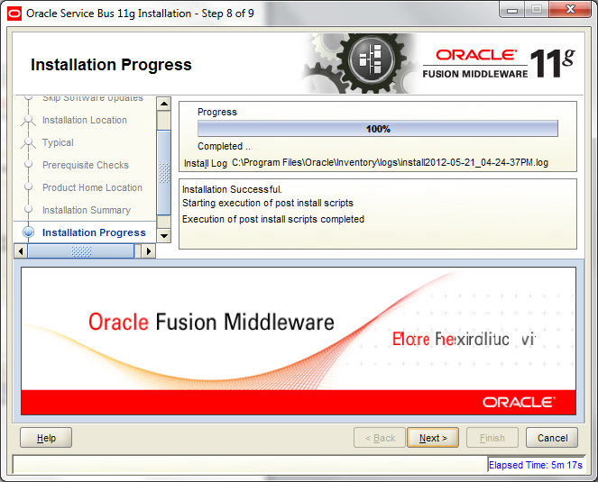

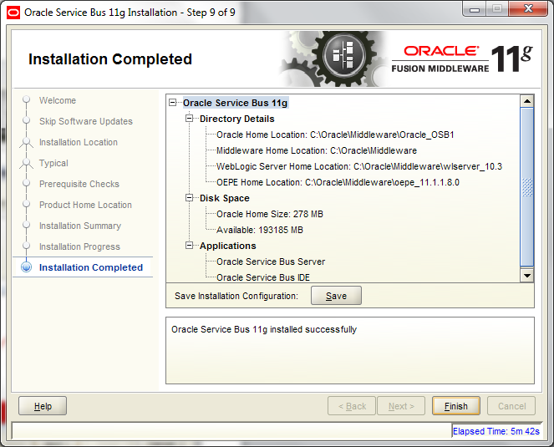

# Install recommended Oracle patch

1. Create a new folder here:

C:\Oracle\Middleware\utils\bsu\cache_dir

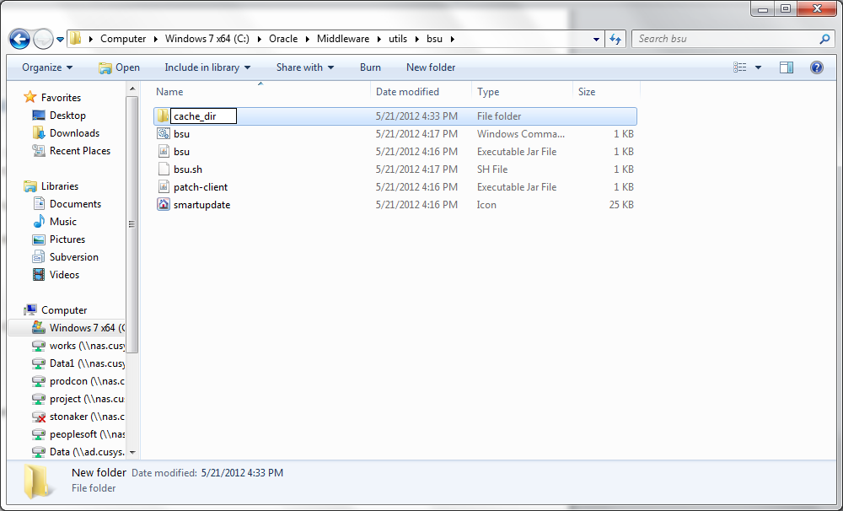

1. Unzip the following two files from the *p13573621_1036_Generic.zip* archive, and copy to the new .\cache_dir folder:
   1. KZKQ.jar
   2. patch-catalog_16794.xml

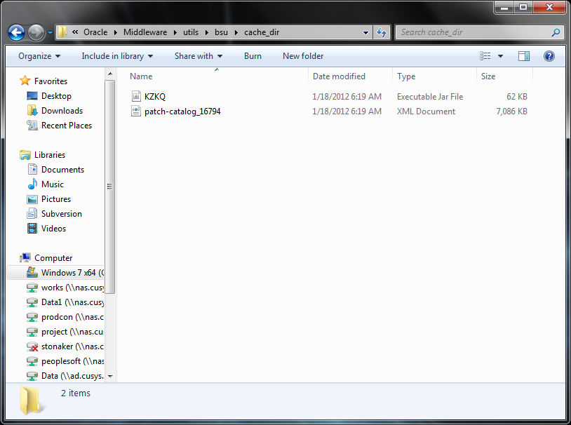

1. Run this program: C:\Oracle\Middleware\utils\bsu\patch-client.jar

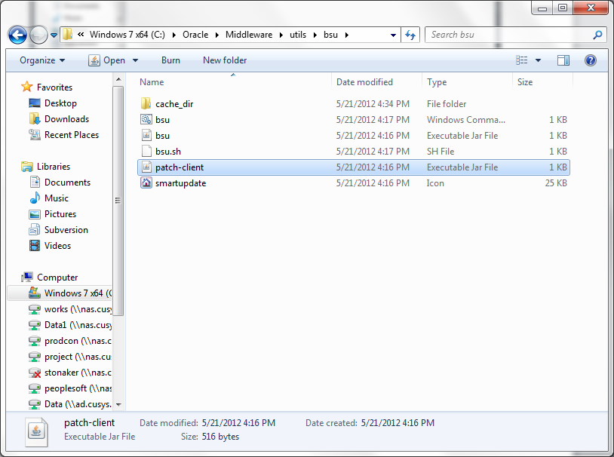

1. On the row with PatchID = “KZKQ”, Click Apply, then Ok

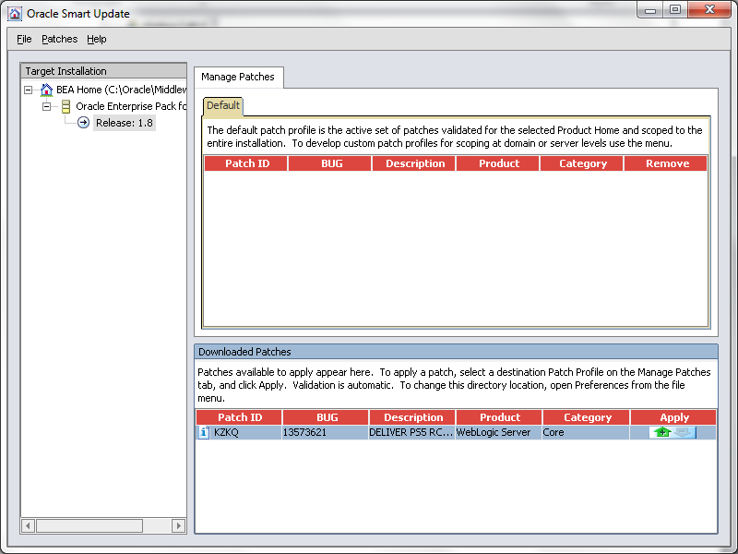

# Configure JIRA Plug-In

1. Open OEPE (launches Eclipse Indigo)
2. Click on the Change Perspective icon:

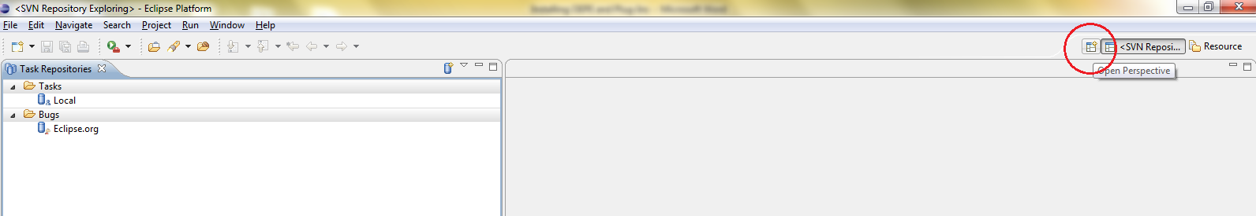

1. Switch to the Planning Perspective:

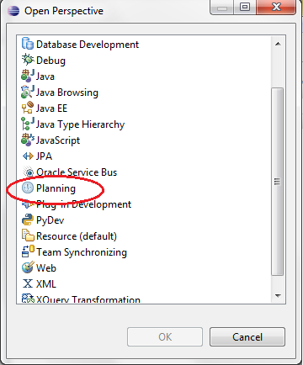

1. Click the down arrow for the first icon next to Task List, choose Add Repository:

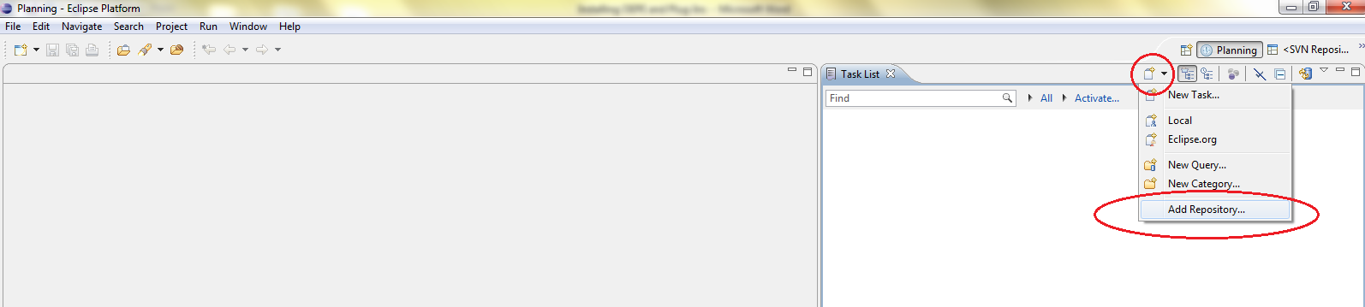

1. Click Install More Connectors

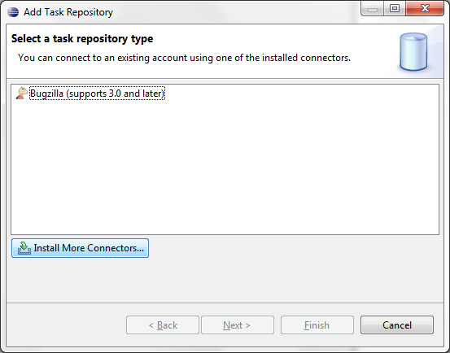

1. Type “JIRA” (without quotes) into the Find box. Check the box next to JIRA, check the box for “Notify when updates are available,” and click Finish:

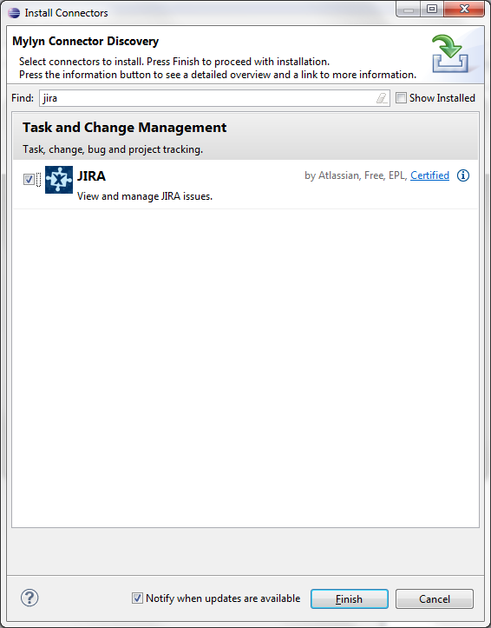

1. Click Next twice on the Mylyn/Atlassian Connector verification dialog:

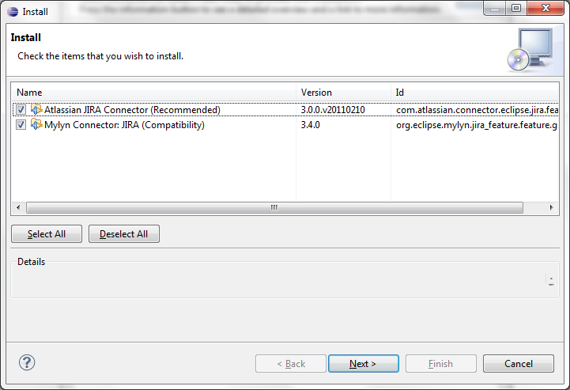

1. Accept the license agreement and click Finish:

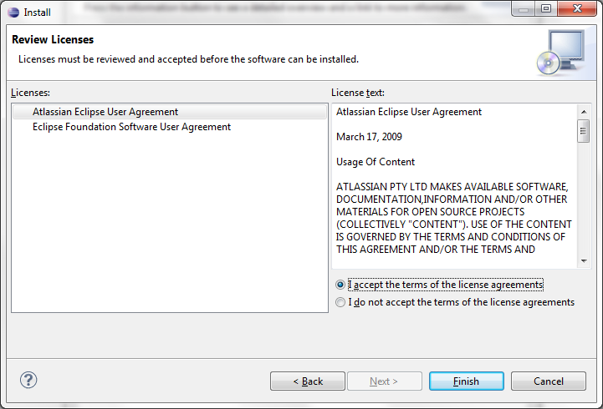

1. Wait for Eclipse to finish installing the software:

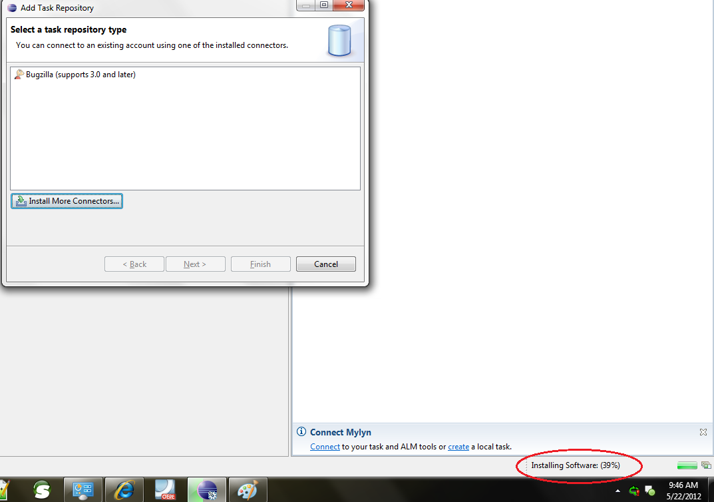

1. Confirm the security warning for unsigned content:

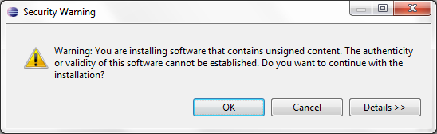

1. Confirm to restart Eclipse (NOT “Apply Changes Now”):

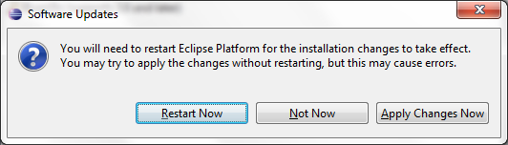

1. Ensure you are in the Planning perspective, and return to the New Repository menu under the Tasks icon:



1. Choose “JIRA”, click Next

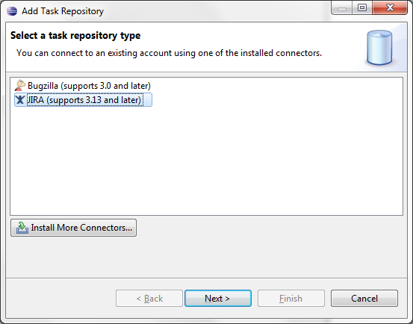

1. Enter the following credentials:

* Server: <https://jira.prod.cu.edu/>
* Label: JIRA (or any label of your choice)
* User ID: Enter your JIRA user ID
* Password: Enter your password (check Save Password if you wish)
* Leave all other options on the default setting
* Click “Validate Settings” when complete.

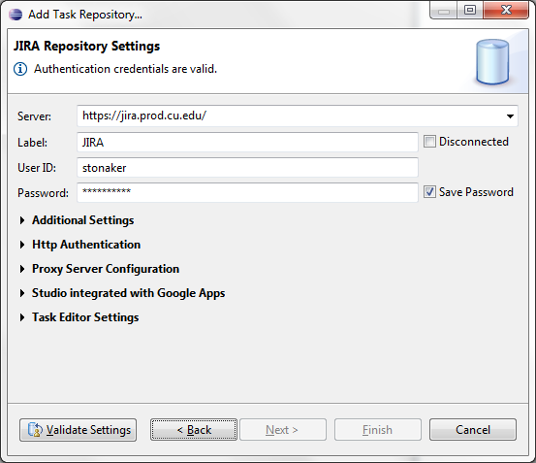

1. Click the Tasks button and click New Query

(In this example, I am creating a query for “all tickets assigned to me”):

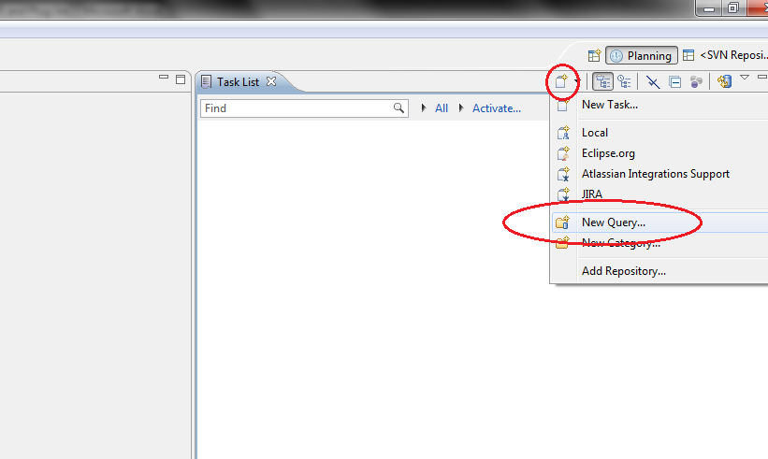

1. Click JIRA then click Next:

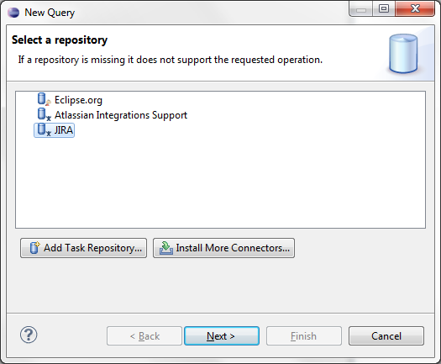

1. Choose “Predefined filter for selected project”, then “All Projects” and “Assigned to me” in the lists presented:

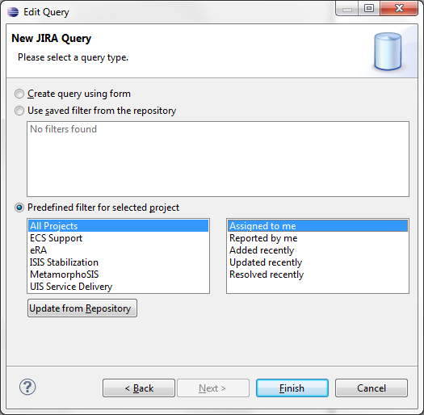

1. Click Finish to view the new Query in the Tasks panel:

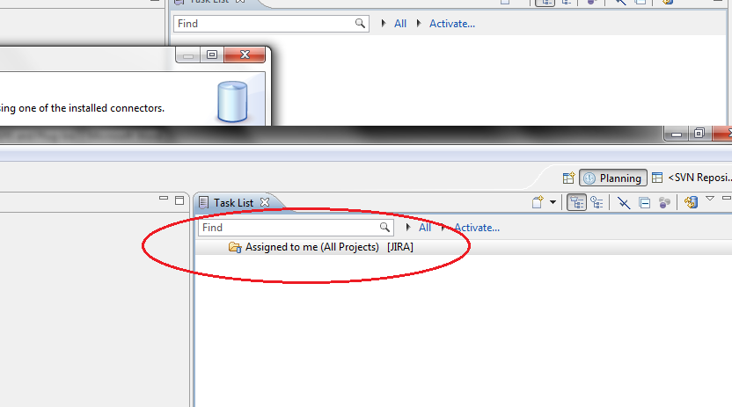

(It only appears blank because there is nothing yet assigned to me, but this was successfully tested by both creating and closing a JIRA ticket only from within Eclipse.)

1. Using similar steps, you can create custom Queries using either predefined filters or direct SQL WHERE clauses.

Configure Subclipse (SVN Plug-In)

1. Choose Help, Install New Software:

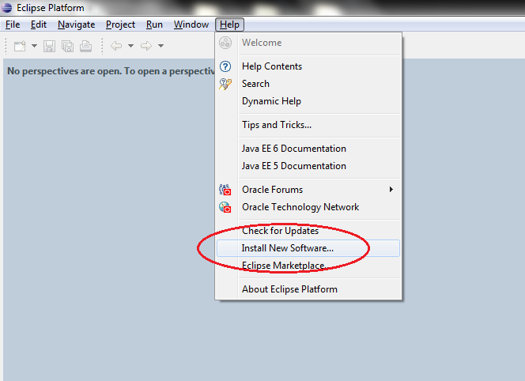

1. Click Add:

* Name: Subclipse
* Location: <http://subclipse.tigris.org/update_1.6.x>
* Click OK

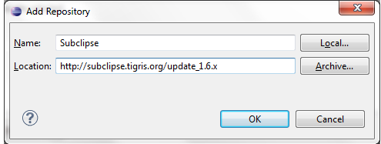

1. Back in the Available Software dialog, ensure the Subclipse location is chosen in the “Work with” drop-down menu:

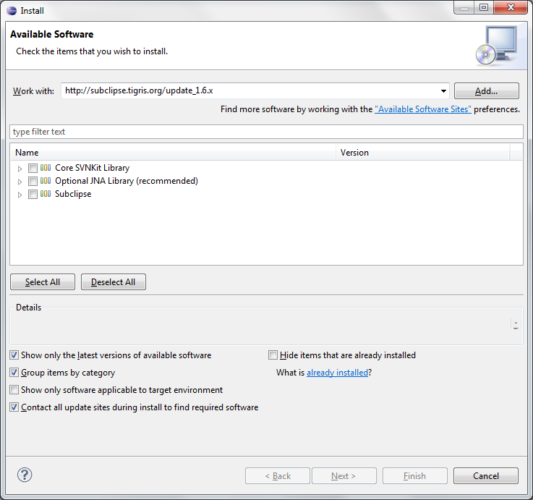

1. Select “Subclipse” (to include all 7 sub-items) and click “Next”

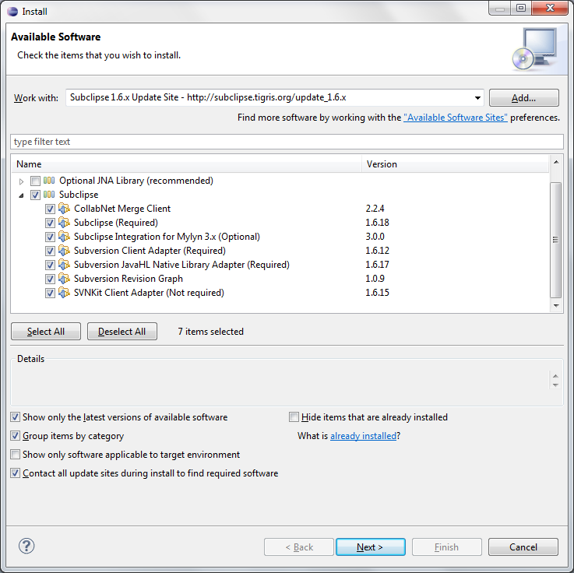

1. Wait for the install to complete (it can take a while):

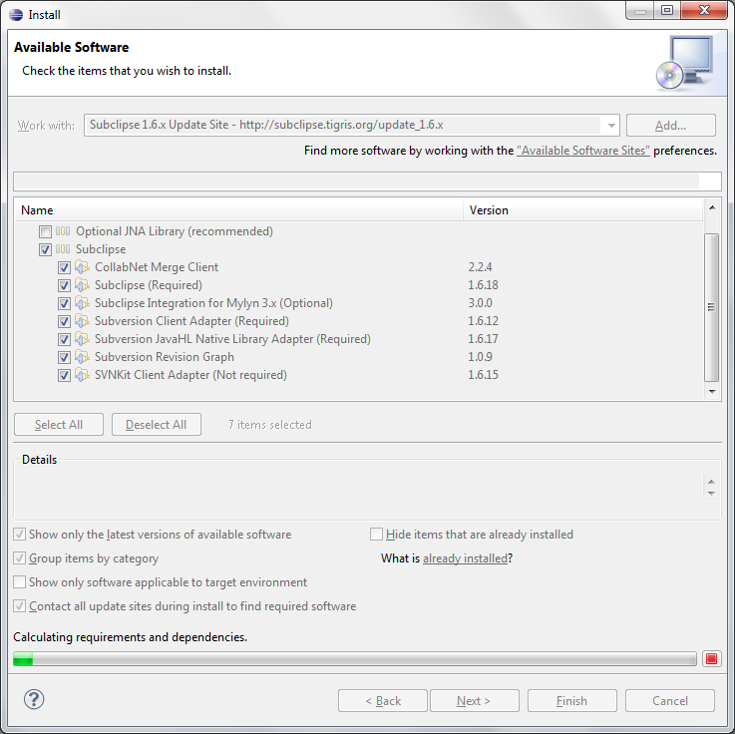

1. Review the Install Details list and click Next:

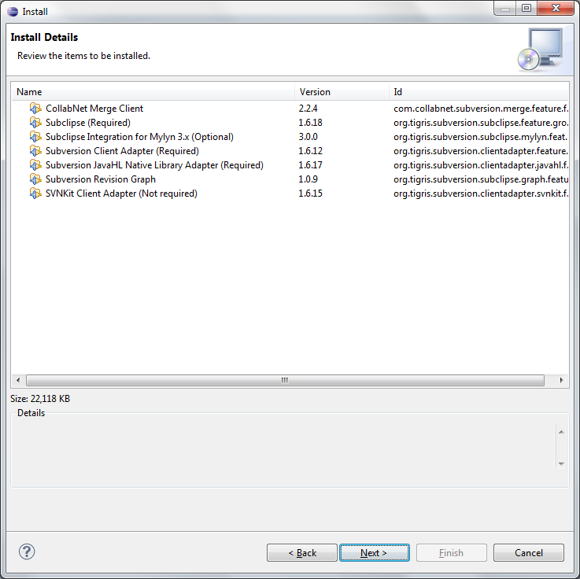

1. Accept the license agreements and click Finish:

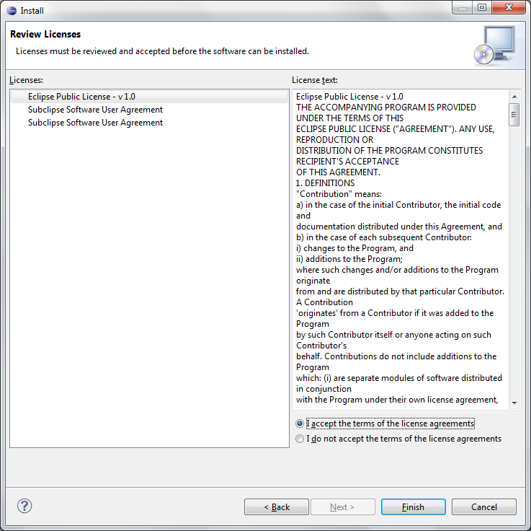

1. Wait a while longer:

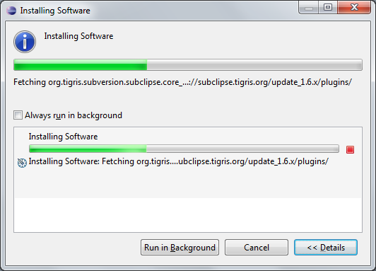

1. Confirm unsigned content once more:

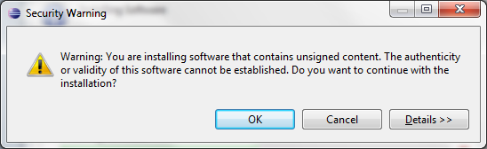

1. Choose “Restart Now” (NOT Apply Changes):

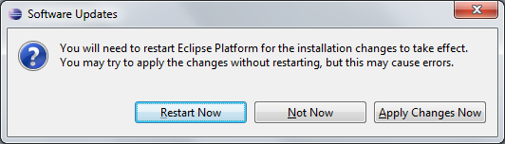

1. Choose Window/Preferences, select Team/SVN page, and change the “SVN interface” client to “SVNKit (Pure Java) SVNKit v1.3.5.7406. Click Apply.

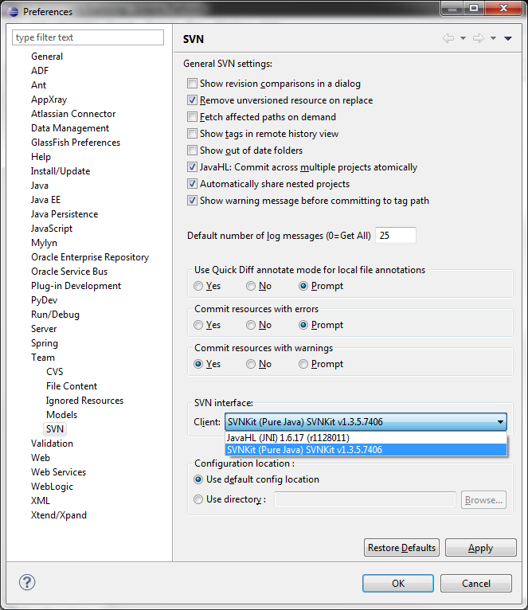

1. Change Perspective to “SVN Repository Exploring”

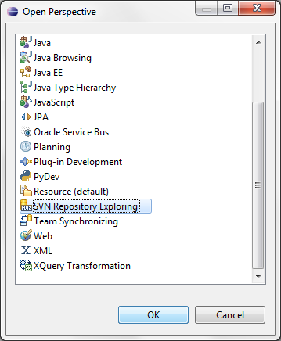

1. Right-Click in the “SVN Repositories” window and choose New/Repository Location:

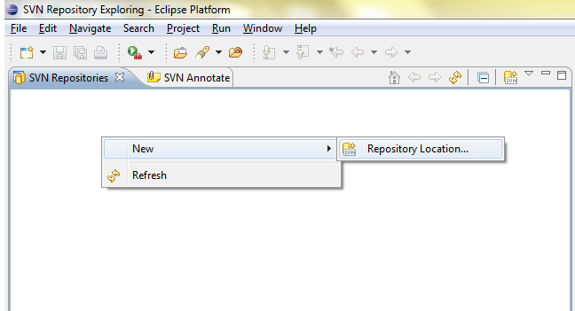

1. Enter this URL in the Add Repository dialog: <http://svn.mgnet.prod.cu.edu/svn/integrations/trunk/>

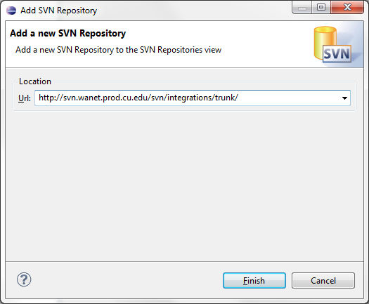

1. The structure from code control appears in the “SVN Repositories” window:

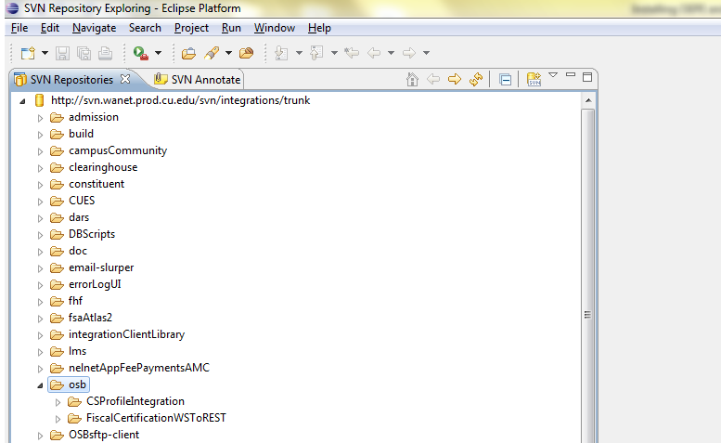

Install SoapUI plug-in

1. Within Eclipse, click on Help / Install New software



1. Click the “Add…” button next to “Work with:” “type or select a site”

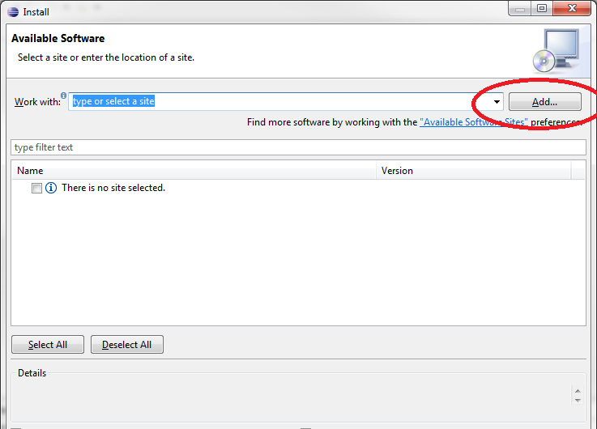

1. Add this site: <http://www.soapui.org/eclipse/update/site.xml>
2. Check the boxes for “soapUI” and “ soapUI Feature version 4.0.1”

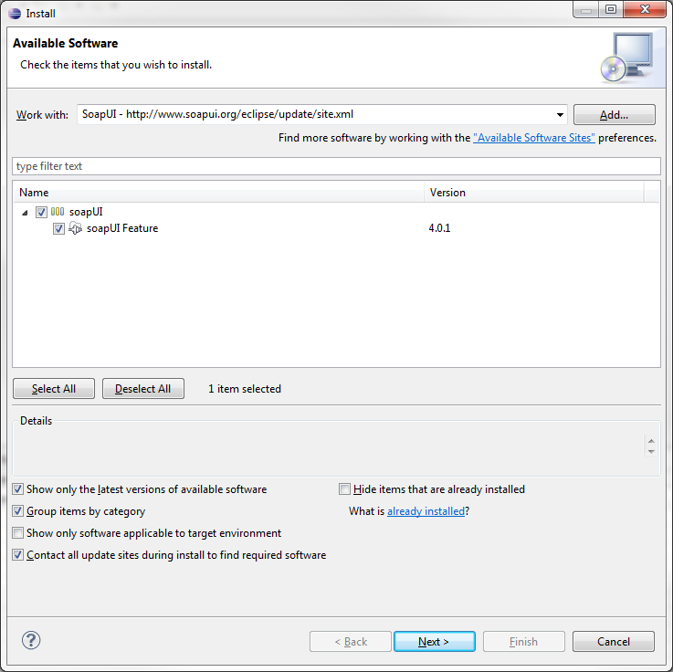

1. Click Next twice
2. Accept the license agreement and click Finish:



1. Wait for Eclipse to finish installing the software:



1. Confirm the security warning for unsigned content:



1. Confirm to restart Eclipse (NOT “Apply Changes Now”):

